**Module 6.1 Capstone**

Stella K Kypton L Julio P  
C460 Capstone   
Professor Osier  
November 14, 2025

**Module 6.1 Capstone**

Resources:   
[Team Two Testing Document](https://docs.google.com/spreadsheets/d/1JLdYrUbcN272lYWvQCl7H2F7uGHXyvqmENtNsd7Eci0/edit?gid=0#gid=0)   
[KanBan Board](https://github.com/users/Stella-Elaine/projects/1/views/1)   
[Moffat-Bay Repo](https://github.com/Stella-Elaine/Moffat-Bay)   
  
**PLEASE WATCH ME to see Navgation tests**<https://www.loom.com/share/86d6d38738374bfc8c5ae72f804a5b6f>   
<https://www.loom.com/share/752085f369ae4f6581cb5c8d878821e5>   
   
  
 **T-1 , T-3 : New User Customers from Login/ Registration Table**  
User Kyle1 and Seth are accounted for on the bottom of table, and used for screenshots.   
**Before Creating Kyle1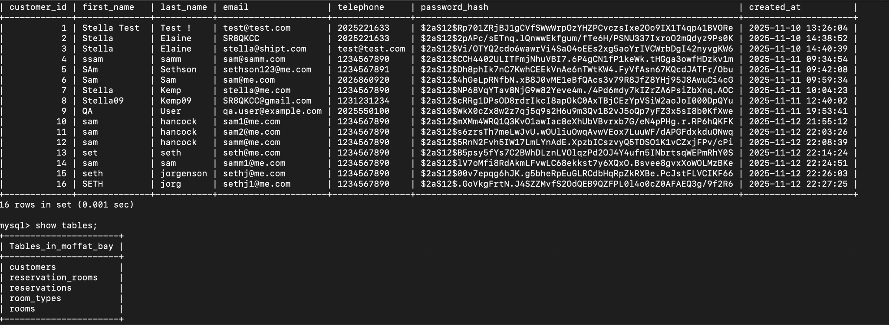  
  
After Creating Kyle1**

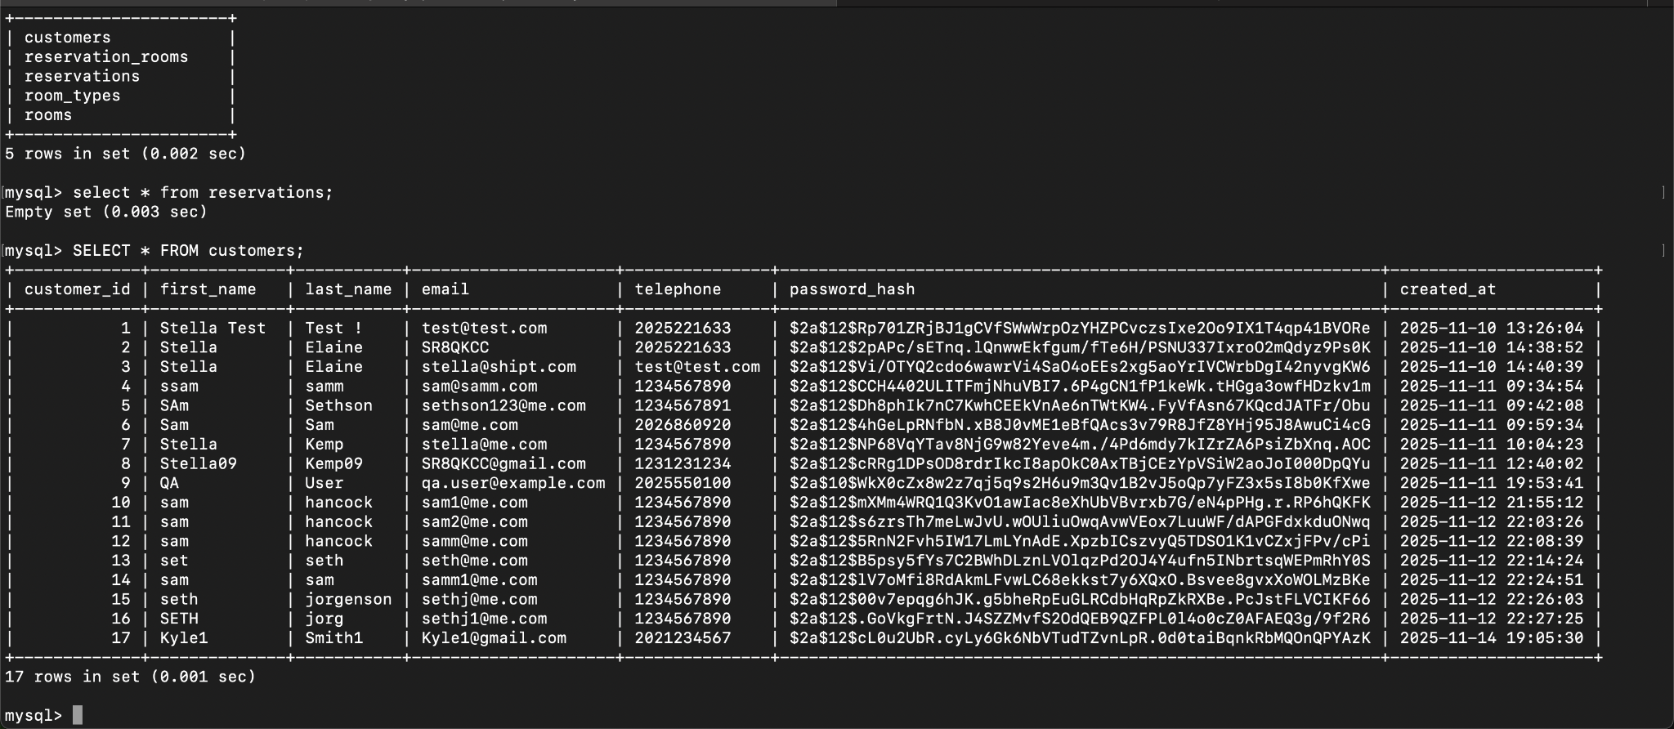

**T-4 : Log in with invalid password**

**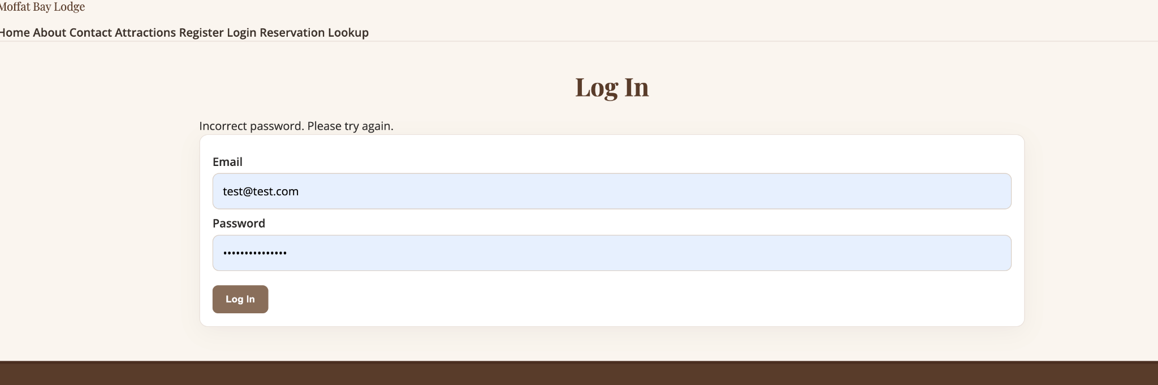  
T-2: Account Creation:   
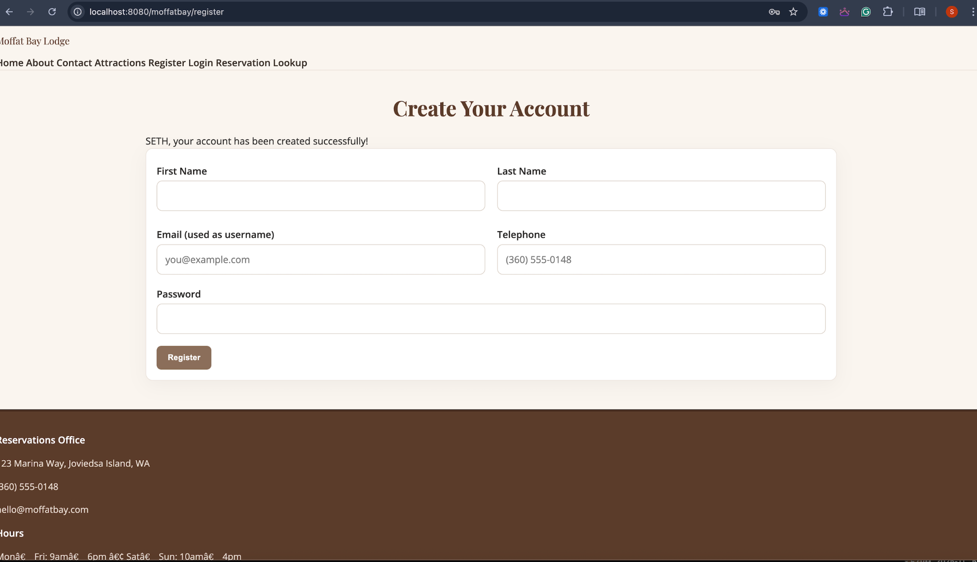  
  
  
T-2: Duplicate Email Registration:   
  
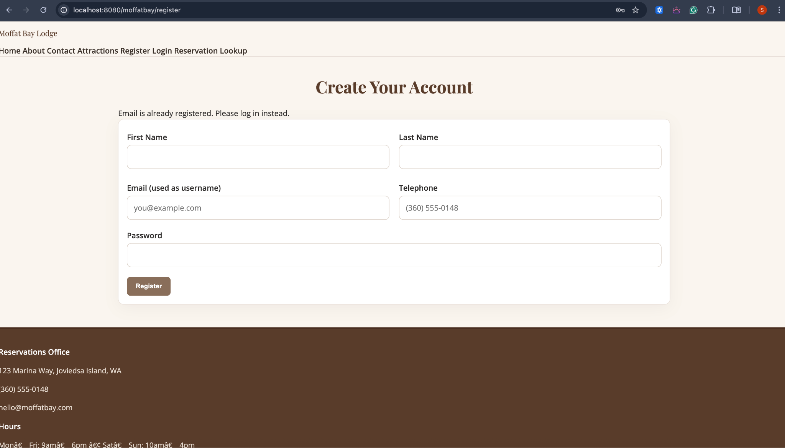  
  
  
T-3: Login Flash Welcome Back Message under the Navigation Bar.   
  
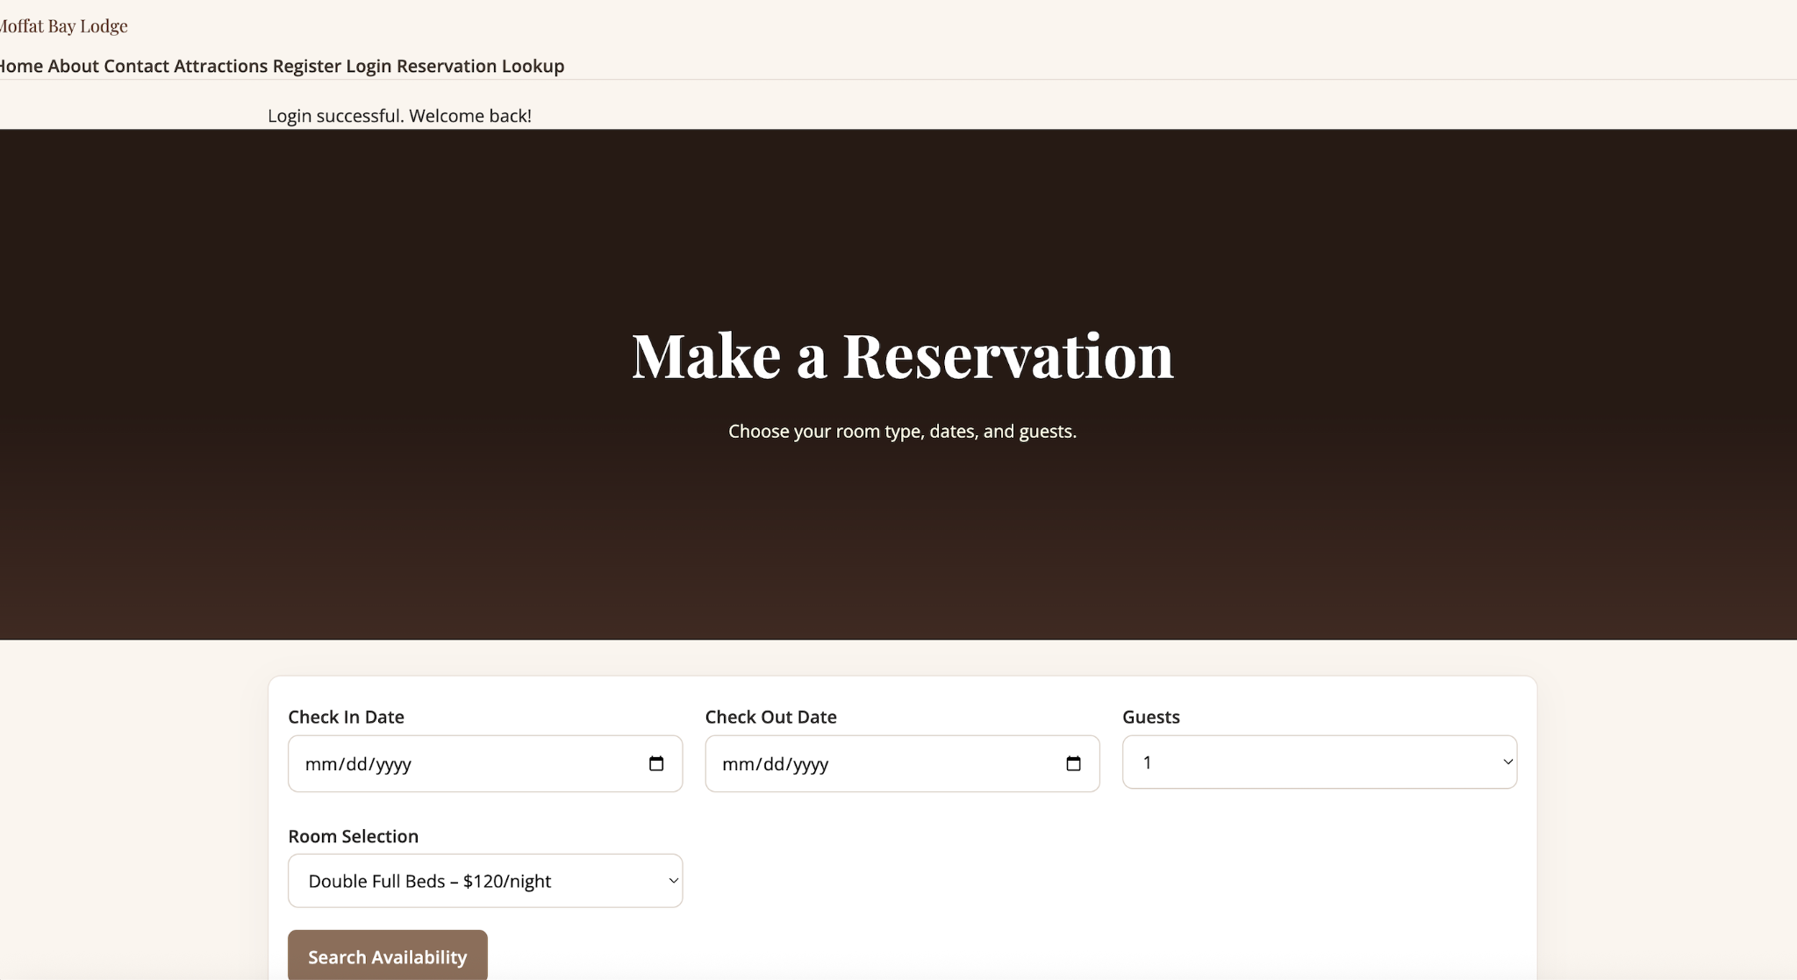  
  
  
  
  
  
T-5: Landing Page   
T-6 :** [**Testing video with navigation**](https://www.loom.com/share/05874b193ea44cc8bbc96828ec17dd8e)  